SAP Integration Suite
Cloud Integration

Technical Specification Document

gSAP_eCustoms_MIC

Version: 1.0
Author: Generated by AI
Date: May 01, 2026
Status: Draft

Table of Contents
1. Change History
1.1 Document Control
2. Overview
2.1 Executive Summary
2.2 Purpose
2.3 Interface Requirement
2.4 Functional Assumptions
2.5 Integration Snapshot
3. High level iFlow Design
3.1 Current Scenario
3.2 To-Be Scenario
3.3 High Level Design
3.4 Technical Dependencies
4. Message Flow
4.1 Process Flow
4.2 Message Flow Connections
4.3 Integration Flow Diagram
5. Technical Description
5.1 Main Integration Process
5.3 Sender
5.4 Receiver
5.5 Mappings
5.6 Security
5.7 Groovy Scripts
5.8 Error Handling & Logging
6. Version and Metadata
7. Appendix
7.1 Technical Artifacts
7.2 Schemas
7.3 Externalized Parameters

1. Change History
Version | Date | Author | Description
1.0 | 2026-05-01 | Generated by AI | Initial autogenerated version

1.1 Document Control
- Document ID: TS-gSAP_eCustoms_MIC
- Integration Flow: gSAP_eCustoms_MIC
- Generated On: 2026-05-01 00:53
- Generation Mode: Batch
- Diagrams Included: Yes
- Functional Spec Context: Provided

2. Overview

2.1 Executive Summary
The gSAP_eCustoms_MIC iFlow facilitates the electronic exchange of export declaration data between gSAP and the MIC-CUST application for customs processing. It automates the submission of export declarations to customs EDI systems, eliminating manual intervention and improving efficiency.

2.2 Purpose
This document provides a technical specification for the gSAP_eCustoms_MIC integration flow, outlining its functionality, configuration, and dependencies.

2.3 Interface Requirement
The need to electronically submit export declarations to customs authorities in France, UK, Belgium & Switzerland from the gSAP system, as stated in the functional specification.

2.4 Functional Assumptions
Assumption | Value
Frequency | Real-time or near real-time, triggered by events in gSAP.
Volume | Dependent on the number of export deliveries processed daily.
Processing Type | Asynchronous, XML-based SOAP messages.
Performance | The iFlow should process messages with minimal latency to avoid delays in customs processing.

2.5 Integration Snapshot
Metric | Value
Integration Processes | 1
Message Flows | 2
Sequence Flows | 11
Groovy Scripts | 4
Schemas | 0
Externalized Parameters | 100

3. High level iFlow Design

3.1 Current Scenario
Manual data transfer or potentially a legacy system with limited automation.

3.2 To-Be Scenario
Automated electronic submission of export declarations from gSAP to MIC-CUST, enabling efficient customs processing for France, UK, Belgium & Switzerland.

3.3 High Level Design
The iFlow uses a SOAP sender adapter to receive messages from gSAP. XSLT mappings and Groovy scripts transform the message to the required format. A SOAP receiver adapter sends the transformed message to the MIC system. Error handling is implemented using an exception subprocess.

3.4 Technical Dependencies
- Runtime platform: SAP CI integration flow 'gSAP_eCustoms_MIC' orchestrates message exchange from GSAP to MIC.
- Inbound interface dependency: path /gsap_ecustomer; SOAP adapter using SOAP 1.x over HTTP; sender auth type RoleBased with role ESBMessaging.send.
- Outbound interface dependency: URL https://ws.eu.micgtm.com/svj/miccustaes-test/services/Export; receiver authentication type Basic with credential/security artifact ecustomer_mic_soap; processing mode cxfRobust.
- Security dependency: sender auth type RoleBased with user role ESBMessaging.send; receiver authentication type Basic with credential/security artifact ecustomer_mic_soap.
- Runtime security and network dependency: WS-Security mode SignMessage; signature algorithm SHA1; token profile WssX509V3Token10; proxy default; timeout 60000 ms and keep-alive 1.
- Design-time artifacts: WSDLs src\main\resources\wsdl\Export.wsdl; src\main\resources\wsdl\MIC_CustomsDeclaration.wsdl | mappings src\main\resources\mapping\Deliveries_to_CustomsDeclaration_XSLT.xsl; src\main\resources\mapping\Deliveries_to_Deliveries_XSLT.xsl.
- Custom script artifacts: callHeaders.groovy; replace_envelop.groovy; script1.groovy; Set File Name.groovy.
- Externalized runtime dependencies: 100 parameter(s) supplied, including Address, Address_Mic, Credential, Auth, UserRole, BusinessObject.

4. Message Flow
A message comes from GSAP into SAP CI through the configured sender channel.
SAP CI processes the payload and sends the final message to MIC through the receiver channel.

4.1 Process Flow
Step | Description
1 | Step 1: gSAP sends delivery information to the Integration Suite.
2 | Step 2: Integration Suite receives the SOAP message from gSAP.
3 | Step 3: The message is transformed using XSLT mappings and Groovy scripts to match the MIC-CUST format.
4 | Step 4: The transformed message is sent to the MIC-CUST system via SOAP adapter.

Flow Attribute | Value
Target System | MIC
Trigger | Event-triggered by gSAP

4.2 Message Flow Connections
Connection | Name
End Message -> MIC | SOAP
GSAP -> Start | SOAP

4.3 Integration Flow Diagram
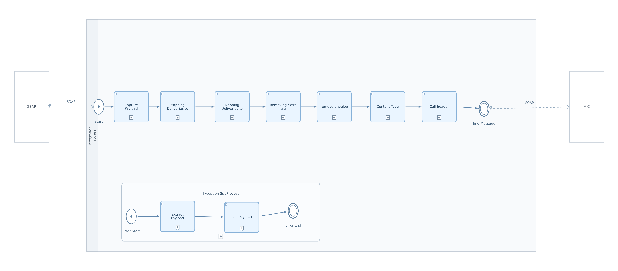
Figure: Integration Flow Diagram

5. Technical Description

5.1 Main Integration Process
Process Name | Sequence Flows | Flow Elements
Integration Process | 11 | 10

Integration Process
This process orchestrates the message flow from gSAP to MIC, including data transformation, header enrichment, and error handling.
Key Activity
SOAP Sender Adapter
Enricher
XSLT Mapping
Groovy Script
SOAP Receiver Adapter
Error Subprocess

Step | Description
1 | Receive message from gSAP
2 | Capture payload and set headers
3 | Transform message using XSLT mappings
4 | Remove extra tags and SOAP envelope
5 | Set Content-Type header
6 | Log header properties
7 | Send message to MIC
8 | Handle exceptions

Key | Value
Transaction Timeout | 30
Transactional Handling | Not Required

callActivity Capture Payload Properties
Key | Value
Body Type | constant

callActivity Content-Type Properties
Key | Value
Body Type | constant

5.3 Sender
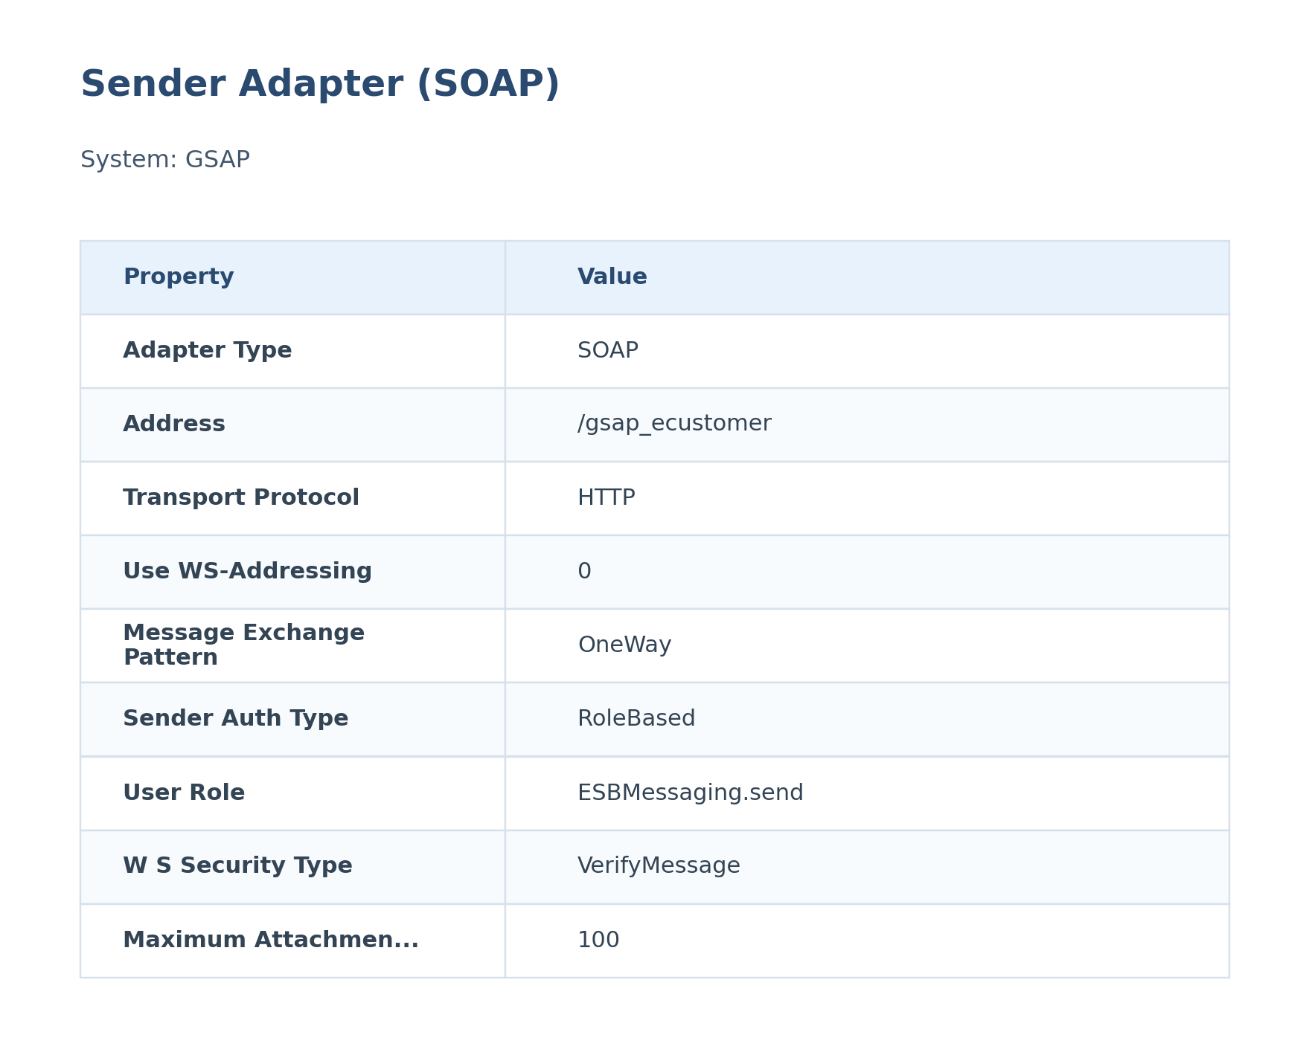
Figure: Sender Configuration

The SOAP sender adapter receives export delivery data from the GSAP system. It is configured to use HTTP protocol and potentially requires authentication based on the 'RoleBased' parameter.
Attribute | Value
Path / Address | /gsap_ecustomer
Adapter Type | SOAP
Protocol | SOAP 1.x over HTTP
Auth Type | RoleBased
User Role | ESBMessaging.send

5.4 Receiver
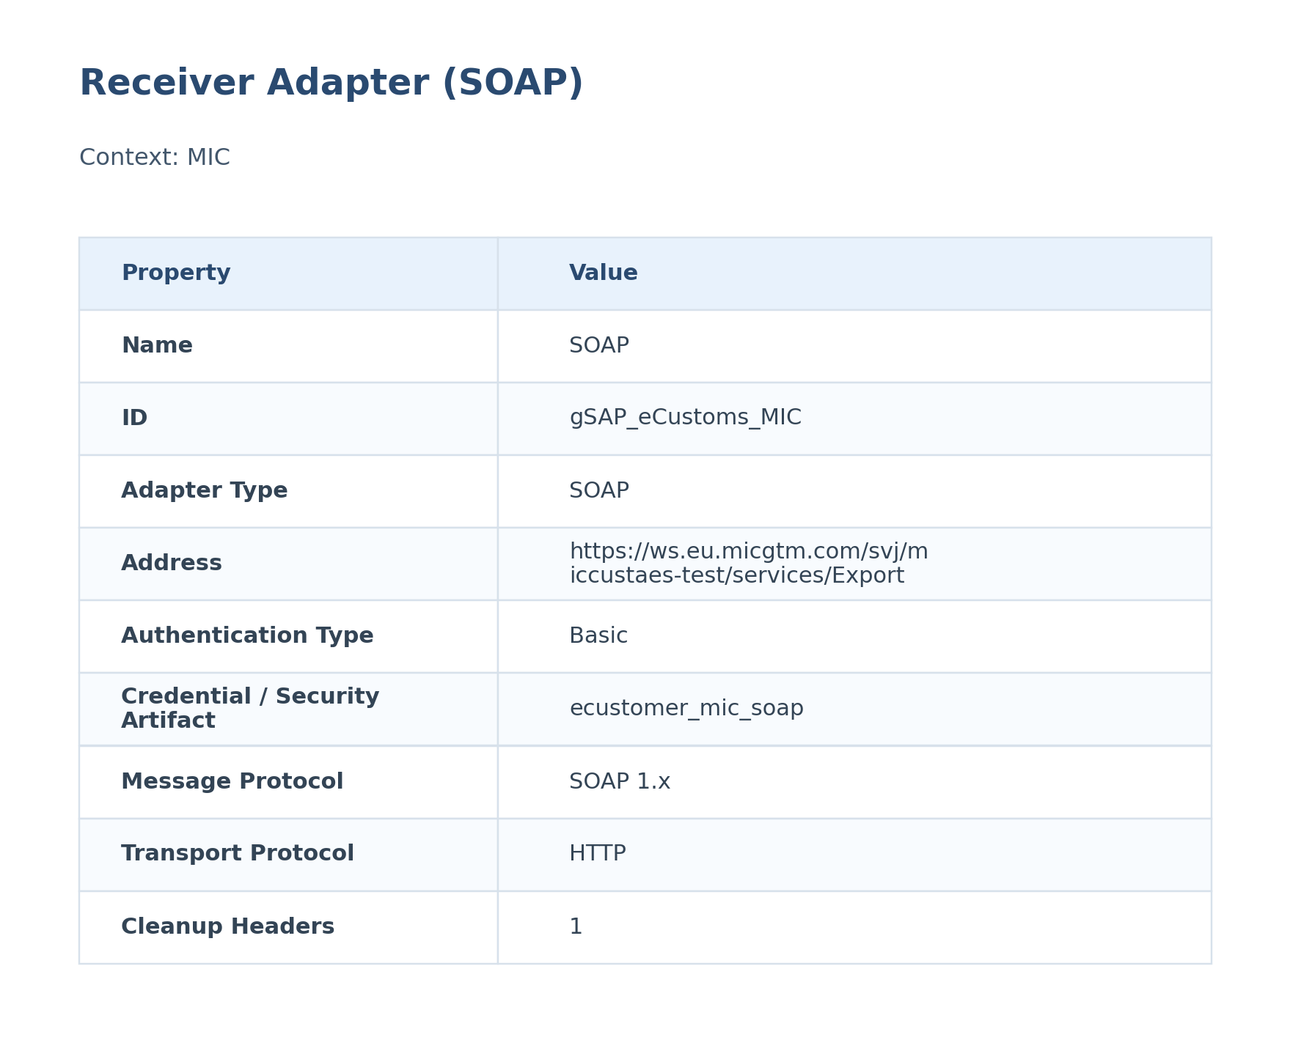
Figure: Receiver Configuration

The SOAP receiver adapter sends the transformed export declaration data to the MIC system. It is configured to use HTTP protocol and requires authentication based on the 'Basic' parameter. WSSecurity is configured for outbound communication.
Attribute | Value
URL / Address | https://ws.eu.micgtm.com/svj/miccustaes-test/services/Export
Adapter Type | SOAP
Authentication Type | Basic
Credential / Security Artifact | ecustomer_mic_soap
Operation Name | Not configured

5.5 Mappings

Deliveries_to_CustomsDeclaration_XSLT
This mapping transforms Deliveries data into the CustomsDeclaration structure used later in SAP CI.
It is executed during message processing to reshape the payload before the next handoff.
Attribute | Value
Source Message / Object | Deliveries
Target Message / Object | CustomsDeclaration
Mapping File | src\main\resources\mapping\Deliveries_to_CustomsDeclaration_XSLT.xsl

Deliveries_to_Deliveries_XSLT
This mapping transforms Deliveries data into the Deliveries structure used later in SAP CI.
It is executed during message processing to reshape the payload before the next handoff.
Attribute | Value
Source Message / Object | Deliveries
Target Message / Object | Deliveries
Mapping File | src\main\resources\mapping\Deliveries_to_Deliveries_XSLT.xsl

5.6 Security
Security Aspect | Details
Authentication | SOAP adapter configured with WSSecurity for outbound communication to MIC. Sender authentication type is not specified in the iFlow.
Authorization | Authorization is likely handled within the MIC system.
Encryption | TLS/SSL encryption is used for communication with MIC.

Key | Value
Namespace Mapping | xmlns:p1=http://service.aes.cust.mic.at
Http Session Handling | None
Return Exception To Sender | false
Log | All events
Cors Enabled | false
Server Trace | false
Access Control Allow Credentials | false

5.7 Groovy Scripts
Groovy scripts are used to perform message manipulation, header enrichment, and logging. They provide flexibility in handling complex data transformations and business logic.

callHeaders.groovy
This script logs header properties (Country, Region, BusinessObject, Sender, Receiver, TimeStamp, messageID) to the message log for auditing and monitoring.
[Groovy]
import com.sap.gateway.ip.core.customdev.util.Message;
def Message processData(Message message) {
def messageLog = messageLogFactory.getMessageLog(message);
if(messageLog != null){
def Country = message.getHeaders().get("Country");
if(Country!=null){
messageLog.addCustomHeaderProperty("Country", Country);
}
def Region = message.getHeaders().get("Region");
if(Region!=null){
messageLog.addCustomHeaderProperty("Region", Region);
}
def BusinessObject = message.getHeaders().get("BusinessObject");
if(BusinessObject!=null){
messageLog.addCustomHeaderProperty("BusinessObject", BusinessObject);
}
def Sender = message.getHeaders().get("Sender");
if(Sender!=null){
messageLog.addCustomHeaderProperty("Sender", Sender);
}
def Receiver = message.getHeaders().get("Receiver");
if(Receiver!=null){
messageLog.addCustomHeaderProperty("Receiver", Receiver);
}
def TimeStamp = message.getHeaders().get("TimeStamp");
if(TimeStamp!=null){
messageLog.addCustomHeaderProperty("TimeStamp", TimeStamp);
}
def messageID = message.getHeaders().get("messageID");
if(messageID!=null){
messageLog.addCustomHeaderProperty("messageID", messageID);
}
}
return message;
}

replace_envelop.groovy
This script removes the SOAP envelope and adjusts namespaces in the message body to prepare it for the MIC system.
[Groovy]
import com.sap.gateway.ip.core.customdev.util.Message;
import java.util.HashMap;
import java.io.*;
def Message processData(Message message) {
def body = message.getBody(java.lang.String) as String;
body = body.replaceAll("<SOAP-ENV:Envelope xmlns:SOAP-ENV=\"http://schemas.xmlsoap.org/soap/envelope/\" xmlns:SOAP-ENC=\"http://schemas.xmlsoap.org/soap/encoding/\" xmlns:xsi=\"http://www.w3.org/2001/XMLSchema-instance\" xmlns:xsd=\"http://www.w3.org/2001/XMLSchema\" ><SOAP-ENV:Body>", "");
body = body.replaceAll("</SOAP-ENV:Body></SOAP-ENV:Envelope>", "");
body = body.replaceAll("<m:sendData xmlns:m=\"http://service.aes.cust.mic.at\">","<m:sendData xmlns:m=\"http://service.aes.cust.mic.at\" xmlns:SOAP-ENC=\"http://schemas.xmlsoap.org/soap/encoding/\" xmlns:SOAP-ENV=\"http://schemas.xmlsoap.org/soap/envelope/\" xmlns:xsd=\"http://www.w3.org/2001/XMLSchema\" xmlns:xsi=\"http://www.w3.org/2001/XMLSchema-instance\">")
//set body
message.setBody(body);
return message;
}

script1.groovy
This script removes extra XML tags and namespaces from the message body.
[Groovy]
import com.sap.gateway.ip.core.customdev.util.Message;
import java.util.HashMap;
import java.io.*;
/* def Message processData(Message message) {
//get Body
def body = message.getBody(java.lang.String) as String;
//replaceNamespace tag
body = body.replaceAll("xmlns:n0=\"urn:sapappl:o2c:cp:eame:exportdeliveries:delivery:620\" xmlns:prx=\"urn:sap.com:proxy:P1B:/1SAI/TAS00000000000000000003:750\"", "");
body = body.replaceAll("xmlns:n0=\"urn:sapappl:o2c:cp:eame:exportdeliveries:delivery:620\"", "");
body = body.replaceAll("xmlns:a=\"urn:sapappl:o2c:cp:eame:exportdeliveries:delivery:620\"", "");
//set body
message.setBody(body);
return message;
}
*/
def Message processData(Message message) {
//get Body
def body = message.getBody(java.lang.String) as String;
//body = body.replaceAll(/<MicExportRequestMessage[^>]*xmlns:soapenv="[^"]*"[^>]*>/, '<MicExportRequestMessage>')
body = body.replaceAll(" xmlns:n0=\"urn:sapappl:o2c:cp:eame:exportdeliveries:delivery:620\" xmlns:prx=\"urn:sap.com:proxy:P1B:/1SAI/TAS00000000000000000003:750\" xmlns:soapenv=\"http://schemas.xmlsoap.org/soap/envelope/\"", "");
body = body.replaceAll("xmlns:n0=\"urn:sapappl:o2c:cp:eame:exportdeliveries:delivery:620\"", "");
body = body.replaceAll("xmlns:a=\"urn:sapappl:o2c:cp:eame:exportdeliveries:delivery:620\"", "");
//set body
message.setBody(body);
return message;
}

Set File Name.groovy
Set File Name.groovy is used within the integration flow. It imports 2 module(s).
[Groovy]
import com.sap.gateway.ip.core.customdev.util.Message;
import java.util.*;
// String DynamicFileName(String DeliveryNumber, String timestamp, String RCVPRN) {
// String ournewfilename = ""
// if (RCVPRN == "WHS_AUM") {
// ournewfilename = "${DeliveryNumber}_${timestamp}.S1A";
// } else if (RCVPRN == "WHS_AUF") {
// ournewfilename = "${DeliveryNumber}_${timestamp}.S1B";
// } else if (RCVPRN == "WHS_DUB") {
// ournewfilename = "sadv";
// } else {
// ournewfilename = "sadv";
// }
// return "ournewfilename"
def Message processData(Message message) {
//def body = message.getBody(Map)
//def RCVPRN = body['RCVPRN']
String RCVPRN = message.getProperty('RCVPRN');
String DeliveryNumber = message.getProperty('DeliveryNumber');
String TimeStamp = message.getProperty('TimeStamp');
String Name='';
if(RCVPRN.equals("WHS_AUM")) {
Name = DeliveryNumber + "_" + TimeStamp + ".S1A";
message.setProperty("FileName1", Name);
println(Name);
} else if(RCVPRN.equals("WHS_AUF")) {
Name = DeliveryNumber + "_" + TimeStamp + ".S1B";
message.setProperty("FileName1", Name);
println(Name);
} else if(RCVPRN.equals("WHS_DUB")) {
Name = "sadv";
message.setProperty("FileName1", Name);
println(Name);
} else {
Name = "sadv";
message.setProperty("FileName1", Name);
println(Name);
}
return message;
}

5.8 Error Handling & Logging
Aspect | Details
Description | The iFlow includes an exception subprocess to handle errors that occur during message processing. The exception subprocess logs the payload and terminates with an error end event.
Exception Handling | The exception subprocess captures the error, extracts the payload, logs the payload using the 'Log Payload' script, and terminates with an error end event.
Alerting | Alerting mechanisms are not explicitly configured in the iFlow. However, the message log can be used to monitor errors and trigger alerts.
Retry Logic | The SOAP adapter may have built-in retry logic for fault message responses from MIC, as mentioned in the functional specification, but this is not explicitly configured in the iFlow XML.

Exception SubProcess Diagram
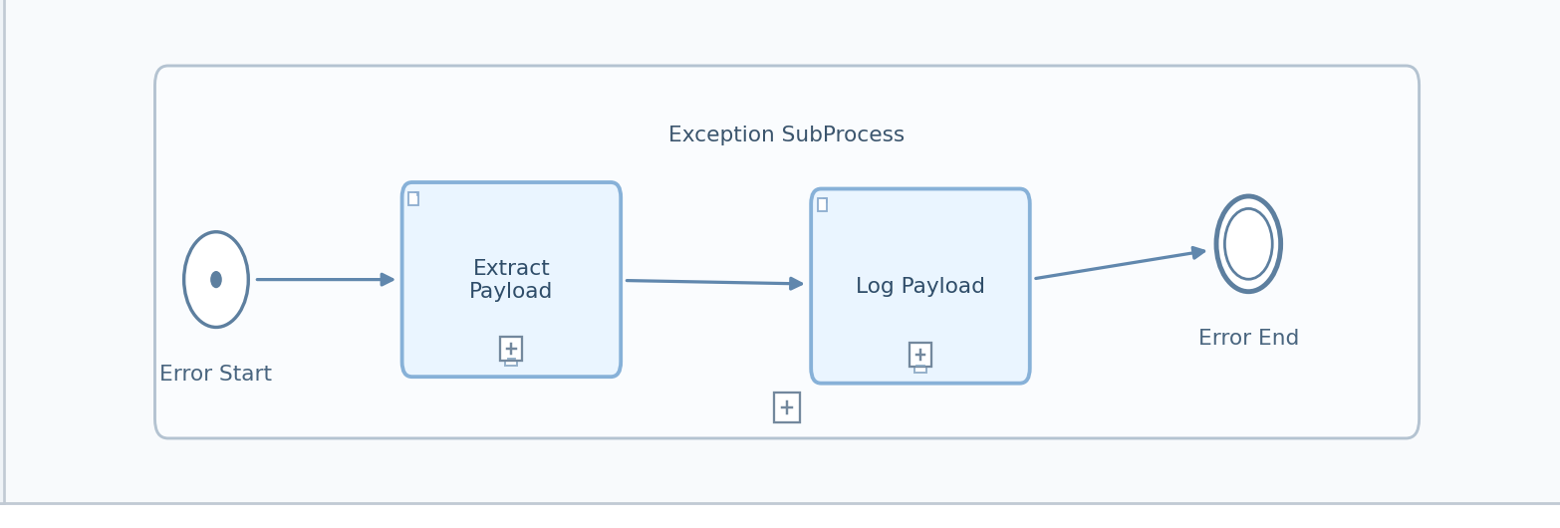
Figure: Exception SubProcess (Copied from Integration Flow Diagram)

Exception SubProcess 1 Properties

Child Element: callActivity Log Payload
Key | Value
subActivityType | GroovyScript
script | Log_Payload.gsh

Child Element: callActivity Extract Payload
Key | Value
bodyType | expression
wrapContent | ${property.InputPayload}

6. Version and Metadata
Key | Value
Componentversion | 1.6
Version | 1.2.4
Package | Not found in iFlow
Author | Not found in iFlow
Description | Not configured

7. Appendix

7.1 Technical Artifacts
- iFlow: gSAP_eCustoms_MIC.iflw
- Groovy Script: callHeaders.groovy
- Groovy Script: replace_envelop.groovy
- Groovy Script: script1.groovy
- Groovy Script: Set File Name.groovy
- Message Flows: 2
- Sequence Flows: 11
- Mapping Activities: 2
- gSAP_eCustoms_MIC.iflw
- Deliveries_to_CustomsDeclaration_XSLT.xsl
- Deliveries_to_Deliveries_XSLT.xsl
- Export.wsdl
- MIC_CustomsDeclaration.wsdl
- Log_Payload.gsh
- Set File Name.groovy
- callHeaders.groovy
- replace_envelop.groovy
- script1.groovy

7.3 Externalized Parameters
Parameter | Value | Used In
Address | /gsap_ecustomer | Sender - Address
Address_Mic | https://ws.eu.micgtm.com/svj/miccustaes-test/services/Export | Receiver - Address
Allow | 1 | Receiver - Allow Chunking
Attachment | 100 | Sender - Maximum Attachment Size
Auth | RoleBased | Sender - Sender Auth Type
Authentication | Basic | Receiver - Authentication
BodySize | 40 | Sender - Maximum Body Size
Clean-up | 1 | Receiver - Cleanup Headers
Compress | 0 | Receiver - Compress Message
Credential | ecustomer_mic_soap | Receiver - Credential Name
End | Not configured | Receiver - Soap Wsdl Port Name
Keep-Alive | 1 | Receiver - Keep Connection Alive
Message_Exhange | OneWay | Sender - Message Exchange Pattern
Operation | Not configured | Receiver - Operation Name
Processing | cxfRobust | Sender - Soap Options
Proxy | default | Receiver - Proxy Type
Return | 1 | Receiver - Send Http Response Code
Service | Manual | Sender - Service Definition; Receiver - Soap Service Name
Service_ | Not configured | Sender - Service Definition; Receiver - Soap Service Name
Timeout | 60000 | Receiver - Request Timeout
URL | Not configured | Receiver - Soap Wsdl U R L
USE | 0 | Sender - Use W S Addressing
UserRole | ESBMessaging.send | Sender - User Role
WS-Configuration | None | Receiver - W S Security Outbound
WS-Security | None | Sender - W S Security

